

**Business Requirement Document**

**OLSS – CR Asset Selling COP – Phase 2**

**PT. Berlian Sistem Informasi**

**Version Control**

|  |  |  |  |
| --- | --- | --- | --- |
| Author | Version | Date | Description |
| Rayang Amiriyanti | V_1.0 | 4 November 2020 | First Version |
|  |  |  |  |
|  |  |  |  |
|  |  |  |  |
|  |  |  |  |
|  |  |  |  |

1. **Document Reviewers**

|  |  |  |
| --- | --- | --- |
| Role | Organization | Name |
| Division head ISM | PT. Berlian Sistem Informasi | Valentinus A. Bay |
| Unit head | PT. Berlian Sistem Informasi | Devilosa I. Kamal |
| Service manager | PT. Berlian Sistem Informasi | Fajar S. Putra |
| Change manager | PT. Berlian Sistem Informasi | Cristin P. Sari Kaunang |
| ITD Operation Head | PT. Dipo Star Finance | Ahmad Fikri |
| Superior | PT. Dipo Star Finance | Irma Verdian |
| Requestor | PT. Dipo Star Finance | Antonius Fedrik |

Contents

1. Introduction and High-Level Requirement 4

1.1. Purpose of Document 4

1.2. High Level Requirement 4

1.3. Need and Benefits of Requirement 4

1.4. Reference/Source Document 4

2. Requirement Description 4

2.1. In Scope 4

2.2. Out Scope 4

2.3. Current Functionality 5

2.4. Proposed Functionality 6

2.5. Workflow Requirement 12

3. Risks and Mitigation 12

4. Glossary 12

5. Annexures 13

6. Appendix 13

# Introduction and High-Level Requirement

## Purpose of Document

The main purpose of this document is to understand and record the requirement from PT. Dipo Star Finance. This document will serve as the main reference document for Print Report in Memo Pengajuan. This document will be sent along with RFC document.

## High Level Requirement

Defined changes in the phase two will be applied in memo pengajuan for type of Car Ownership Program only. The changes are in report of memo pengajuan where we will provide template for memo termination and memo pretermination. The expected changes are mostly the enhancement of the report format where system will provide more necessary information as based on user requirement. The elaboration of detail requirements will be mentioned in the section of Proposed Functionality in Business Requirement Document (BRD).

## Need and Benefits of Requirement

With these changes, DSF can maximize their work and time efficiently with the system that can support them to input their existing data and helping them to create detailed-report to adapt with their business process.

## Reference/Source Document

CR Number IT-CFR-200420-855 Asset Selling COP #46850.

# Requirement Description

## In Scope

Scope of this CR is limited to:

1. Report of Memo Pengajuan for COP
2. Update Screen in Memo Pengajuan for COP
3. Lampiran Memo Pengajuan

## Out Scope

1. Profit Analysis
2. Lampiran Hasil Investasi
3. Report of Profit Analysis
4. PJB Report
5. Disposal Report

## Current Functionality

**Print Memo Pengajuan in COP**

Currently user can download the report of memo pengajuan in COP from print report. User is provided one type only of memo pengajuan which is memo termination. Before user can download the report, user need to fill the required data from update screen in memo pengajuan.

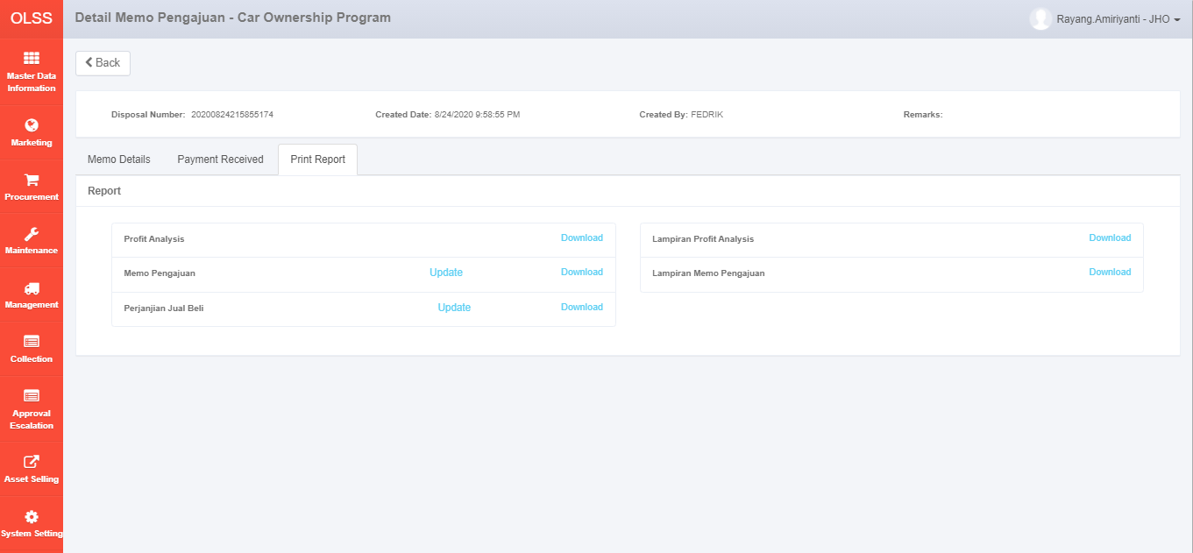

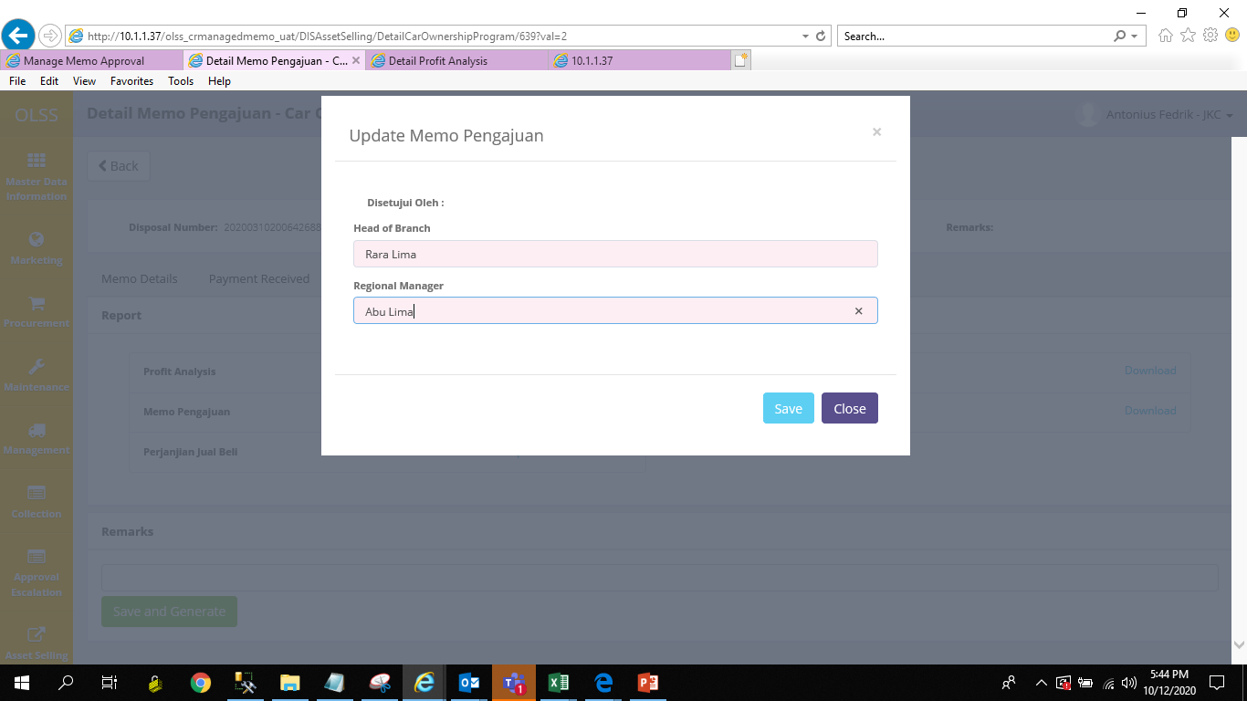

**This Selling Price Amount is getting from the value in Profit Analysis (iv)**

After user click save, the report will be displayed as below:

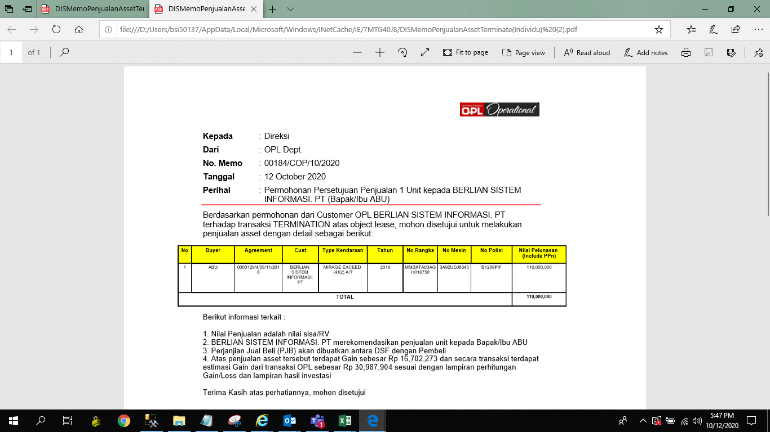

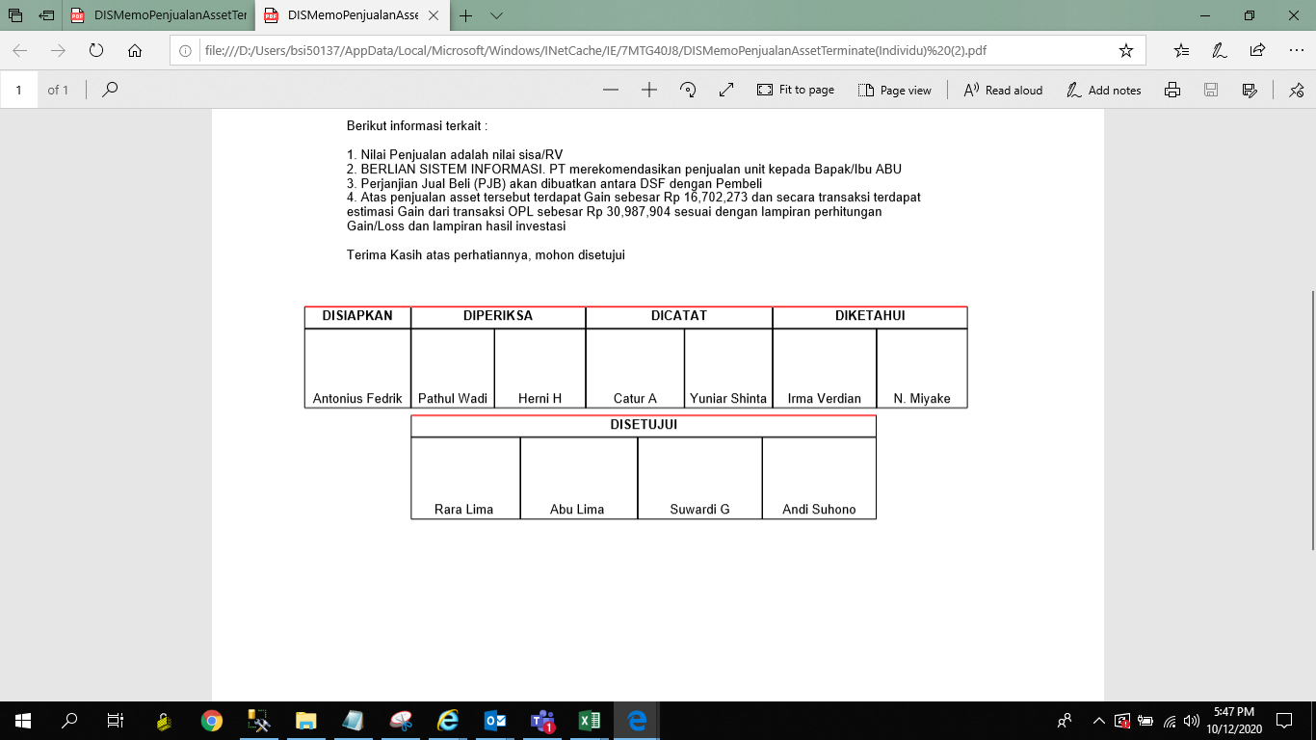



## Proposed Functionality

We will describe changes that will be applied in memo pengajuan for COP. Asset selling currently have two types of memo which are memo termination and memo pretermination. Previously in Phase 1, we have provided print report for memo termination. Then we will continue to accommodate memo pretermination in phase 2. Since there will be two types of memo, we will provide options in update screen for user to choose the type of memo before they want to download the memo.

1. **Update Screen in Memo Pengajuan – Car Ownership Program**

**Business Requirement:**

There are two types of memo which are memo termination and memo pretermination. Thus, user expect to be given options to choose the type of memo before they want to download it.

**Before:**





Current Functionality:

When user There is no options for user to choose the type of memo since in current system we only provide report for memo termination.

**After:**

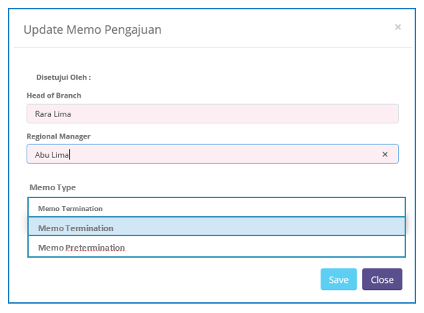





Proposed Functionality:

The new dropdown menu will be provided in update screen. User will be given two options which are memo termination or memo pretermination. Once user click save, then the report will be displayed as what user has chosen in this screen.

1. **Memo Termination & Memo Pretermination**

**Business Requirement:**

* Report will be updated by only showing information about total unit and customer name in “Perihal” info.

**Before:**

Current Functionality:

Memo provides total unit, customer and buyer names in Perihal.

**After:**

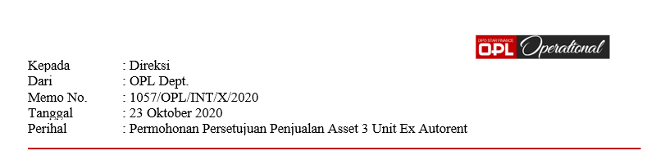

Propose Functionality:

Memo will provide only total unit and customer names in Perihal.

* Report will modify the text content where type of memo will be described along with customer name, buyer name, total gain/loss, and total profit/loss.

**Before:**



Current Functionality:

Previously this information was provided below the table and consists with some detail information which user want to inform within this memo.

**After:**

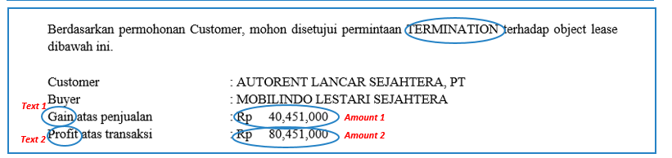

Propose Functionality:

* This information will be provided before the table.
* The type of memo will be described in here. If it’s memo termination then text will be appeared as “TERMINATION” and if it’s memo pretermination then the text will be appeared as “PRETERMINATION”.
* Below is the description of elements which appear as the detail in memo:

a) *Customer name*: the name of customer as based on memo.  
b) *Buyer name:* the name of buyer as what user has input when create memo.  
c) The validation of gain and profit will be described as below:

|  |  |
| --- | --- |
| **Feature** | **Function / Data Source** |
| **Text 1** | Add text as **Gain** if **Data 1** is showing **Positive Numbers** and add text as **Loss** if **Data 1** is showing **Negative Numbers**. |
| **Amount 1** | The data amount will be taken from **Gain/Loss** which existed in **Lampiran Memo Pengajuan**. |
| **Text 2** | Add text as **Profit** if **Data 2** is showing **Positive Numbers** and add text as **Loss** if **Data 2** is showing **Negative Numbers**. |
| **Amount 2** | The data amount will be taken from **Profit/Loss** which existed in **Detail Profit Analysis Screen**. |

* Update and add new data in table where some data in lampiran memo pengajuan will appear in this table. Hence memo pengajuan will provide data of agreement, type kendaraan, years, no.rangka/no.mesin, no.polisi, harga beli, nilai pelunasan (include PPn), Impairment (only appear when data is provided in memo), BV, PPn, and Gain/Loss. These data will be appeared as in one table.

**Before:**

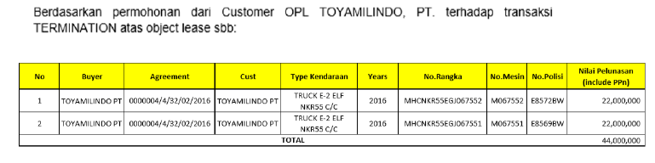

Current Functionality:

Previously memo provide one table consists of *buyer*, *agreement*, *customer*, *vehicle type, years, no.rangka, no.machine, police number, repayment value and the total pay*. And these data are provided as based on the received data for each memo.

**After:**

|  |  |  |  |  |  |  |  |  |  |  |  |
| --- | --- | --- | --- | --- | --- | --- | --- | --- | --- | --- | --- |
| NO | Agreement | Type Kendaraan | Years | No.Rangka/No.Mesin | No.Polisi | Harga Beli | Nilai Pelunasan (include PPn) | PPN | BV | Impairment | Gain/Loss |
| 1 | 0000382/4/01/11/2019 | ISUZU PANTHER MINIBUS | 2015 | MHFXW42G5E2288872 | B1382BIQ | 120,000,000 | 107,800,000 | 9,800,000 | 78,000,000 | 1,000,000 | 20,000,000 |
| 2 | 0000463/4/01/04/2020 | DAIHATSU GRAN MAX 1.3D BLIND VAN | 2015 | MHKG2CJ1JFK029947 | B2973BFJ | 70,000,000 | 66,451,000 | 6,041,000 | 49,583,340 | 2,000,000 | 10,826,660 |
| 3 | 0000463/4/01/04/2020 | DAIHATSU GRAN MAX 1.3D MINIBUS | 2015 | MHFXW42G5E2288834 | B1382BIT | 65,000,000 | 61,232,600 | 5,566,600 | 46,041,660 | 2,000,000 | 9,624,340 |
| **TOTAL** | | | | | | | **235,483,600** | **21,407,600** | **173,625,000** | **5,000,000** | **40,451,000** |

Propose Functionality:

Take out the column of buyer and customer names. And add new column which consists data *Harga beli, PPN, BV, Impairment,* and *Gain/Loss*. And these data are provided as based on the received data for each memo.

* Update the box of signature where there is additional text for user can add the date below of approval name.

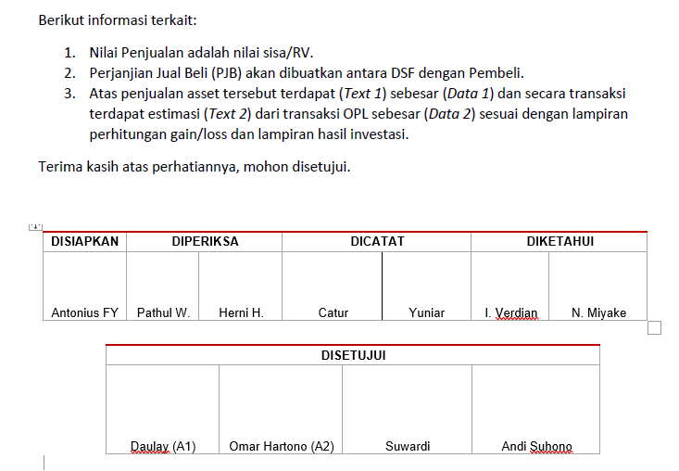**Before:**

Current Functionality:

Memo only provides name of the approval.

**After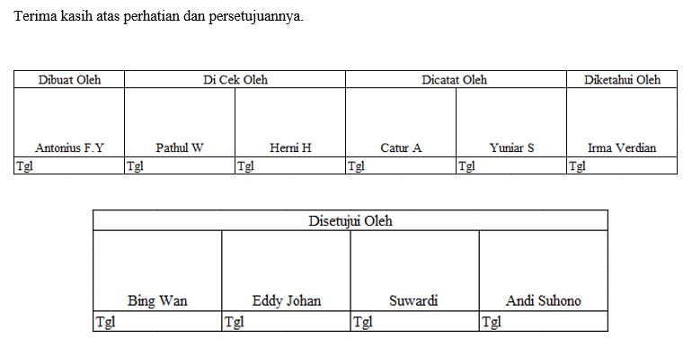:**

Propose Functionality:

Memo will provide approval name and new row for input date of the approval.

## Workflow Requirement

**Memo Pengajuan COP**

There is one flow that will be added in memo pengajuan COP.

**Before:**

User click **Download** in *Print Memo Pengajuan* to get the report.

User click **Update** in *Print Memo Pengajuan*

User input data Head of Branch and Regional Manager then click save

**After:**

*New flow*

User input data Head of Branch and Regional Manager

User need to choose the type of memo from drop down menu then click save

User click **Download** in *Print Memo Pengajuan* to get the report.

User click **Update** in *Print Memo Pengajuan*

# 3. Risks and Mitigation

The error possibility could be found in other report such as in PJB, Disposal Report, and Profit Analysis Report since they use the same object list.

**Mitigation:**

Conduct several testing processes to make sure these risks will not occur when we applied the changes.

# 4. Glossary

1. DSF – PT. Dipo Star Finance
2. BSI – PT. Berlian Sistem Informasi

# 5. Annexures

|  |  |  |
| --- | --- | --- |
| **No** | **Document Name** | **Attachment/Path** |
| **1** | **RFC CR Asset Selling COP Phase 2** |  |

# 6. Appendix

**Display propose full report:**

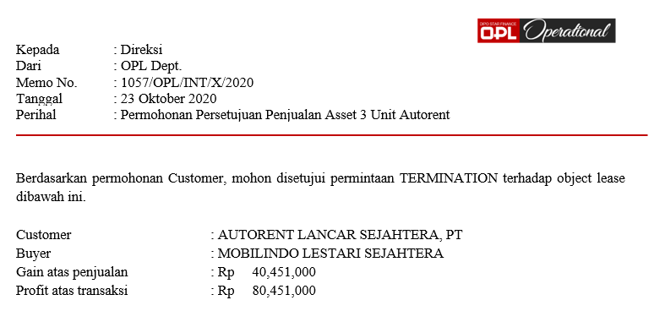

|  |  |  |  |  |  |  |  |  |  |  |  |
| --- | --- | --- | --- | --- | --- | --- | --- | --- | --- | --- | --- |
| NO | Agreement | Type Kendaraan | Years | No.Rangka/No.Mesin | No.Polisi | Harga Beli | Nilai Pelunasan (include PPn) | PPN | BV | Impairment | Gain/Loss |
| 1 | 0000382/4/01/11/2019 | ISUZU PANTHER MINIBUS | 2015 | MHFXW42G5E2288872 | B1382BIQ | 120,000,000 | 107,800,000 | 9,800,000 | 78,000,000 | 1,000,000 | 20,000,000 |
| 2 | 0000463/4/01/04/2020 | DAIHATSU GRAN MAX 1.3D BLIND VAN | 2015 | MHKG2CJ1JFK029947 | B2973BFJ | 70,000,000 | 66,451,000 | 6,041,000 | 49,583,340 | 2,000,000 | 10,826,660 |
| 3 | 0000463/4/01/04/2020 | DAIHATSU GRAN MAX 1.3D MINIBUS | 2015 | MHFXW42G5E2288834 | B1382BIT | 65,000,000 | 61,232,600 | 5,566,600 | 46,041,660 | 2,000,000 | 9,624,340 |
| **TOTAL** | | | | | | | **235,483,600** | **21,407,600** | **173,625,000** | **5,000,000** | **40,451,000** |

